Title
Version: | 0.1
Author(s): | DH
Created: | 02/16/2009
Last modification: | 02/16/2009

Version | Date | Author(s) | Changes
0.1 | 2/16/2009 | DH | Initial version.
Contents
1. User Interface 2
1.1. Overview 2
1.2. Public Welcome Page 2
1.3. Logged in View 3
1.4. User Pages 5
1.4.1. Workitems 5
1.4.2. Profile Settings 6
1.4.3. Change Tenant 7
1.5. Workflow Admin Pages 8
1.5.1. Create Instance 8
1.5.2. Show Workflow Instances 9
1.5.3. Show Userlist 10
1.6. Tenant Admin Pages 11
1.6.1. Create / Edit Workflow Models 11
1.6.2. Tenant settings 13
1.6.3. Edit Userlist 15
1.7. Super Admin Pages 16
1.7.1. Edit Tenants 16
1.7.2. Approve Tenants 17
1.7.3. System Settings 18
1.7.4. Show /Edit Users 19

User Interface

Overview
This section gives a brief overview of the DecidR user interface. The user interface will be explained in detail in the external document Error: Reference source not found. The information in this section and the external document can deviate from each other. Due to the fact that this section should give just a first impression, it will not be updated and the information in the external document is valid in case of deviation.

The User Interface allows the user to interact with the DecidR System. It allegorizes the interface between the user and the application logic. It is accessible by Internet Explorer Vers.7 and Mozilla Firefox 3. The interface is optimized for a resolution of 1024x768 upwards.

Public Welcome Page
On the public welcome page the user has the opportunity to view information about DecidR, help pages, terms of service and impressum. Furthermore he is able to login, register and request a password reset of his user account.
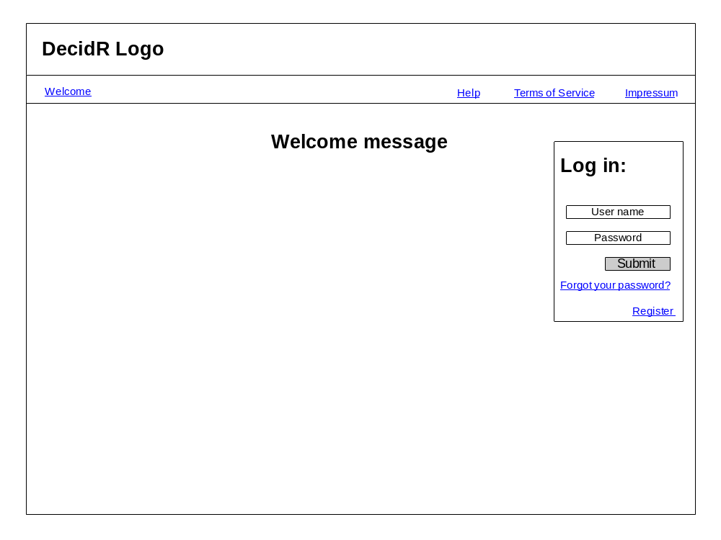
Figure 1: public welcome page

Logged in View
The following picture shows the general layout of the interface for logged in users:
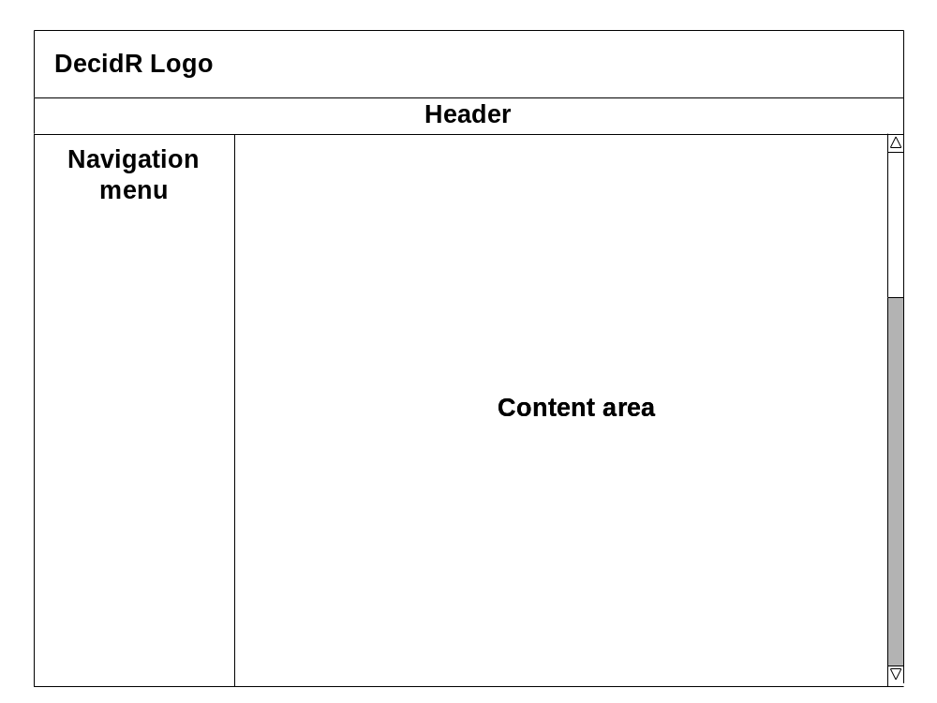
Figure 2: general layout for logged in users
In the logged in status the user has furthermore the opportunity to view help pages, terms of service and impressum. He also is able to logout.

On the left side, you can see the navigation bar. It has to be adjusted for each user role. Due to the fact that the “higher” users have also the rights of the lower ones, the items of a lower user are also shown for the higher one. A full navigation bar has the following entries:
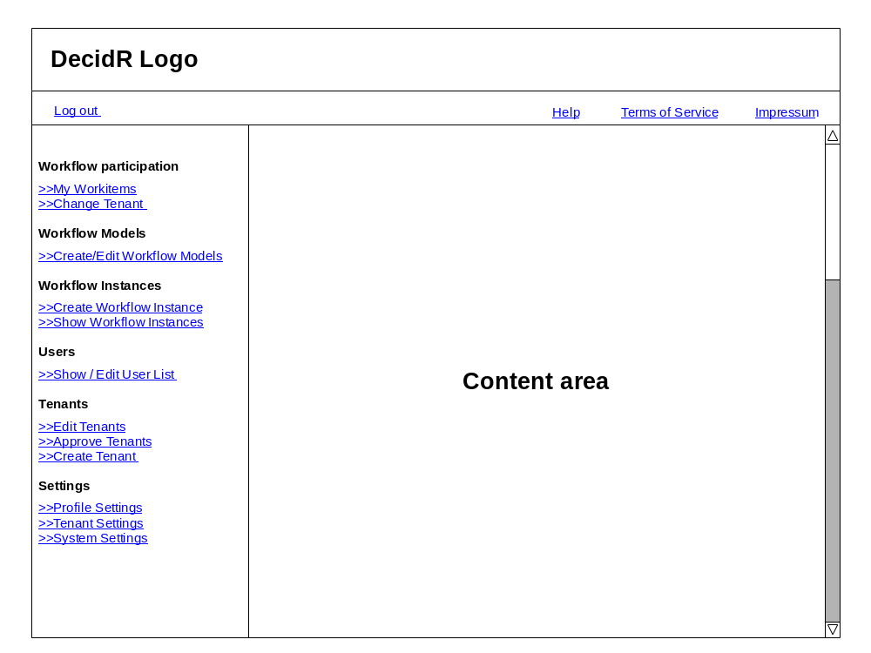
Figure 3: complete navigation menu
The entries for the different user roles are:

User:
  - Workitems
  - Profile Settings
  - Change Tenant

Workflow-Admin:
  - Create Workflow Instance
  - Show Workflow Instances
  - Show Userlist

Tenant Admin:
  - Create/Edit Workflow Models
  - Tenant Settings
  - Edit Userlist

Super-Admin:
  - Edit Tenants
  - Approve Tenants
  - System Settings

User Pages

Workitems
In the navigation bar, the number of new work items will be shown in brackets next to the entry “My Workitems”. The work item page shows a table with all user specific work items of the current tenant. Furthermore the user has the possibility to work on a work item or to mark a work item as done.
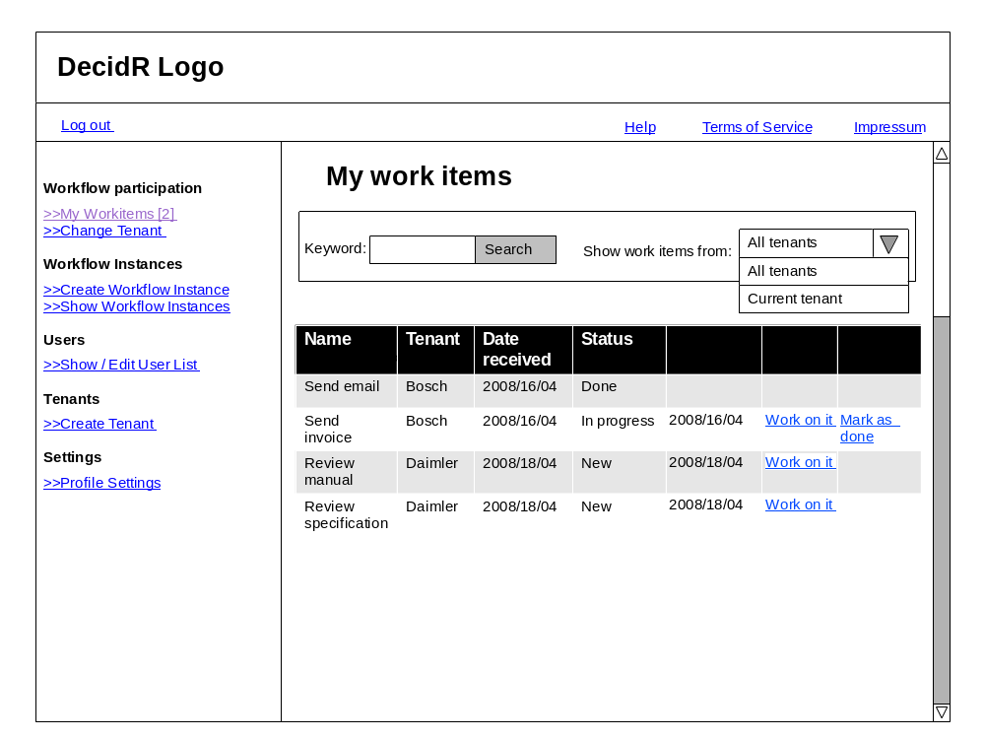
Figure 4: my work items
The User also has the possibility to sort/filter the list and to show all work items, means also the work items of the other tenants he takes part.

Profile Settings
In this section the user can change his profile settings and set his status to inactive.
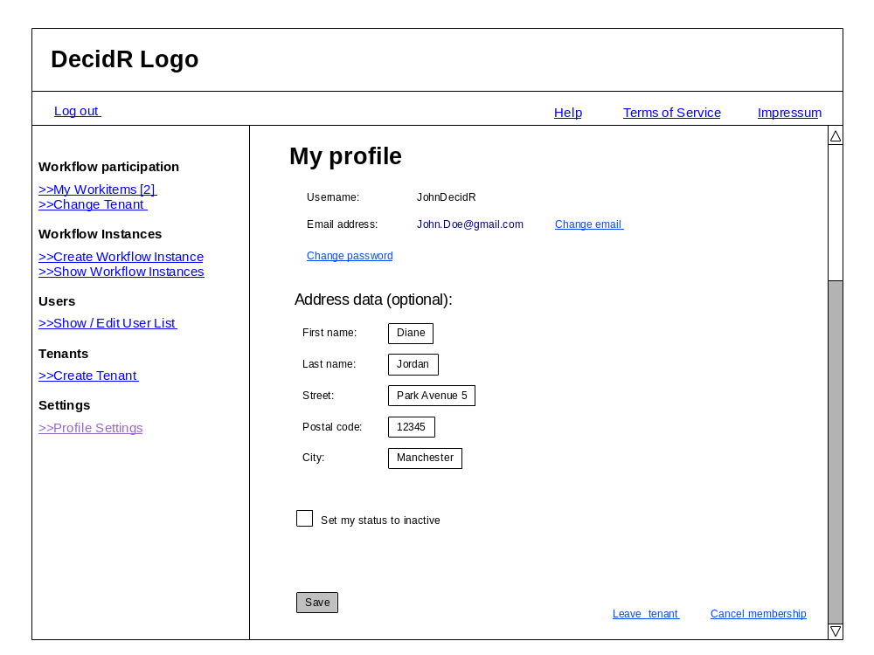
Figure 5: profile page

Change Tenant
In this section the user can switch between tenants. A List of all tenants the user is member of is shown. By clicking on a switch button next to a tenant name he can change to this tenant.
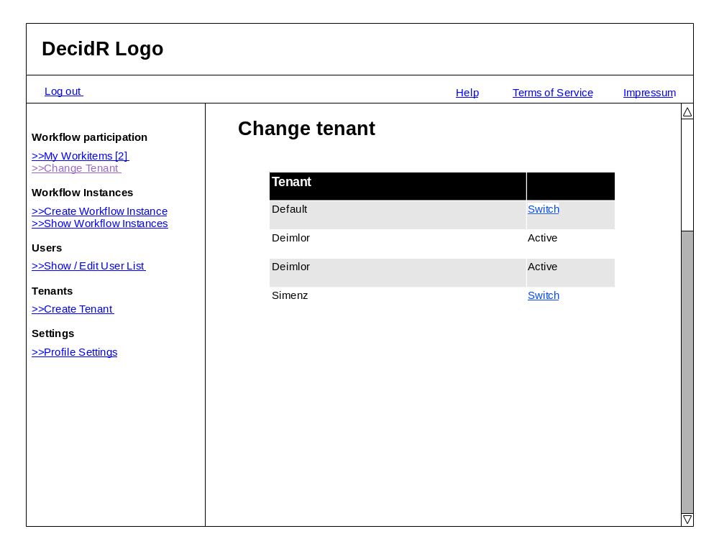
Figure 6: change tenant page

Workflow Admin Pages

Create Instance
On this page all workflow Models the workflow admin has access to are shown. He is able to create an instance of one of the models by clicking on the “create instance” button next to the model name. He is also able to filter the workflow models.
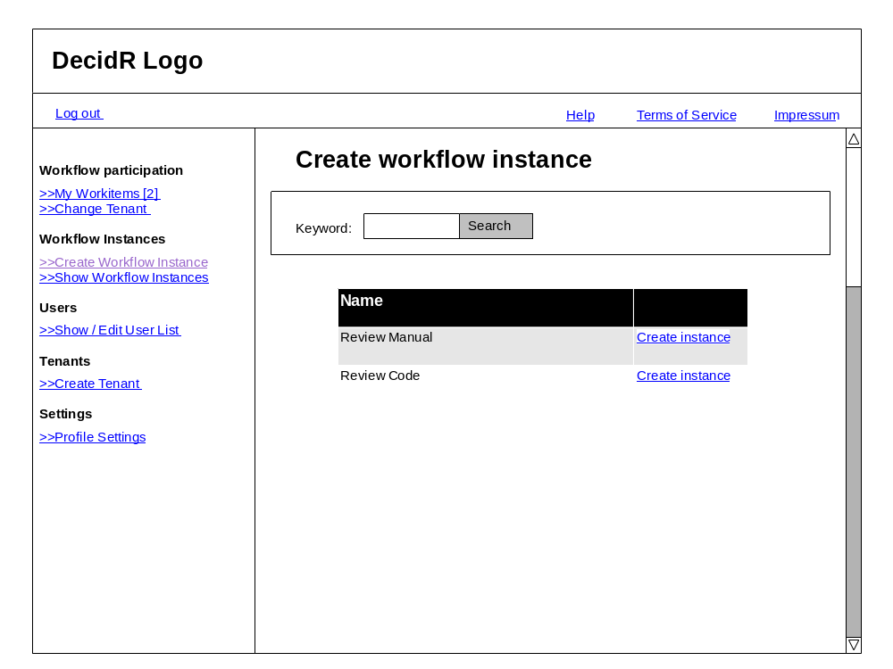
Figure 7: create workflow instance
After clicking on a “create instance” button, the user have to set the model specific variables and to assign users to the instance.

Show Workflow Instances
In this section the user can see all running instances of the current tenant and if required he can stop them.
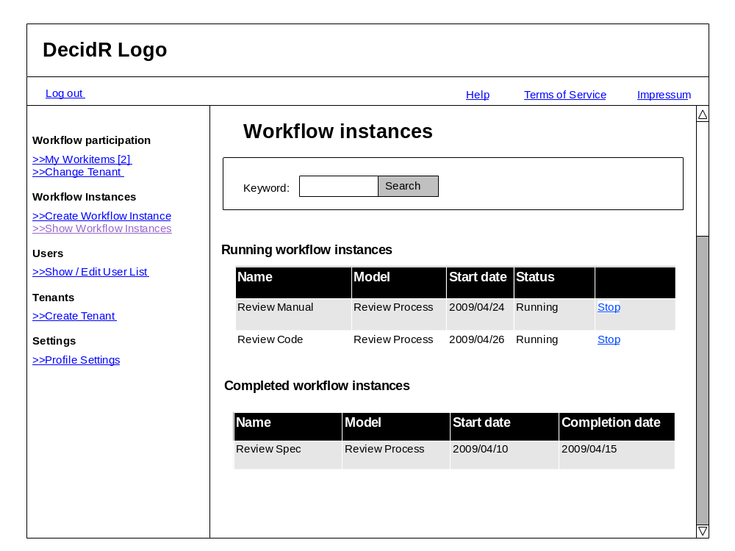
Figure 8: show workflow instances

Show Userlist
By using this item the workflow admin can view all users, which are a member of the tenant.
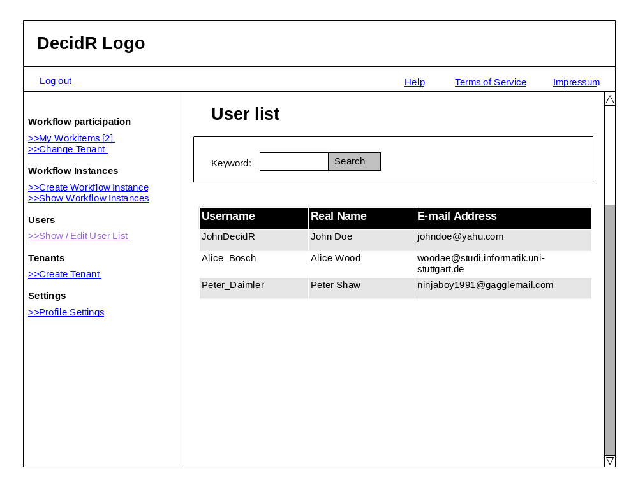
Figure 9: show userlist

Tenant Admin Pages

Create / Edit Workflow Models
Here the User can see a list of all public and tenant specific workflow models. The user is able to create a new workflow models and to edit, delete, publish or un-publish and to appoint the workflow administrators to tenant specific models.
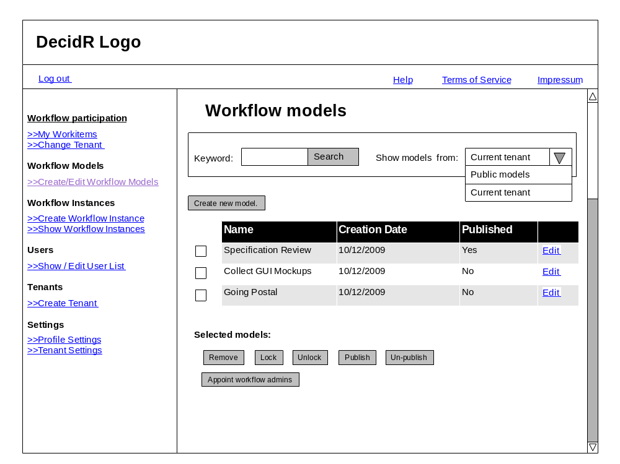
Figure 10: workflow model view (current tenant)
He can change the view to the public mode by using the combo box. In this view he is able to import one or more public models to his tenant.
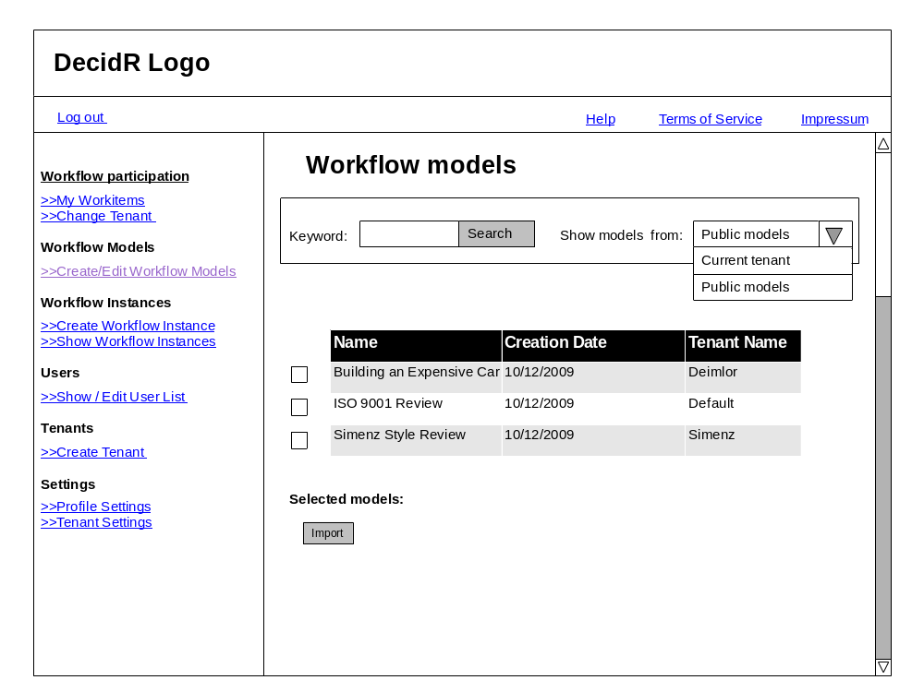
Figure 11: workflow model view (public models)
By pressing edit button in the “current tenant view”, the user is able to change the model and the model name.

Tenant settings
On this page the user can change the tenant specific data. He can set an information text, a logo and the tenant specific color scheme. Furthermore he can navigate to the advanced settings.
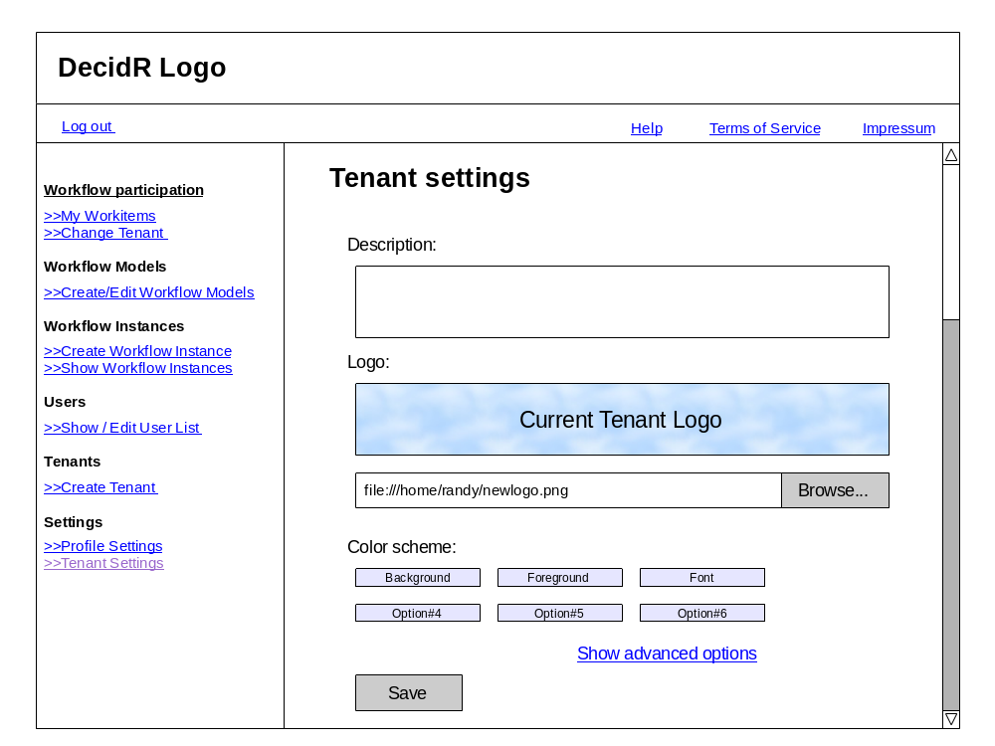
Figure 12: tenant settings (simple)
In the advanced setting he is abele to set the color scheme by using a css file.
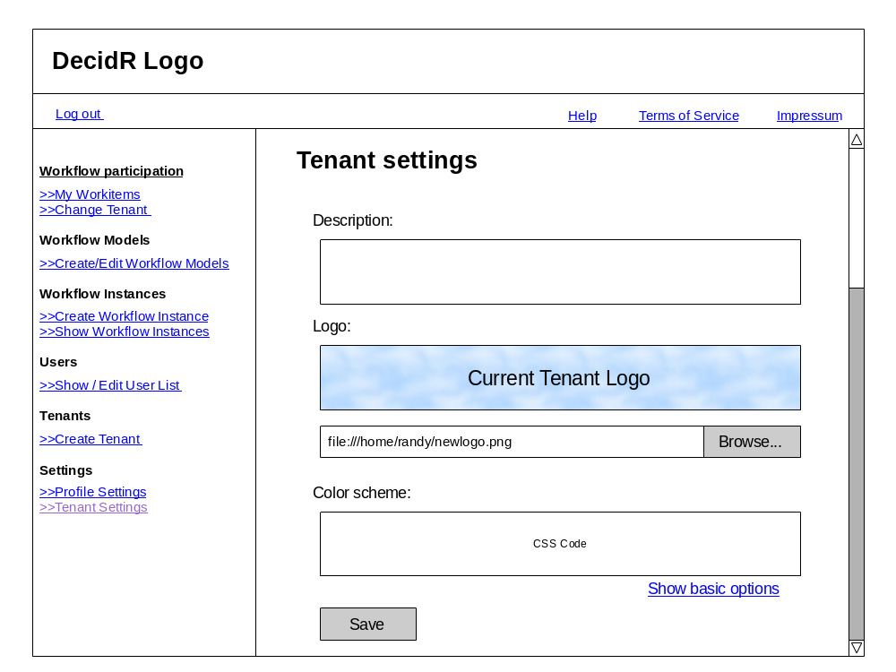
Figure 13: tenant settings (advanced)

Edit Userlist
On this page, the user can delete and invite users to the tenant. Furthermore he can change the user data. He also can filter the shown information.
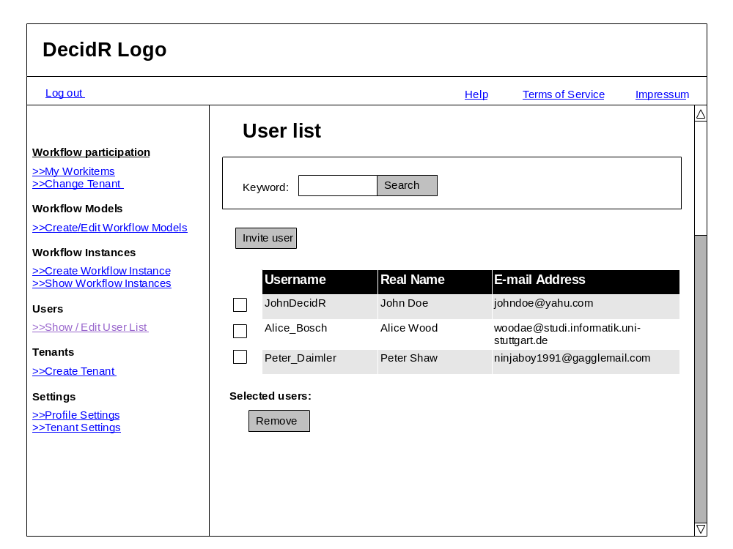
Figure 14: edit user list (tenant admin)

Super Admin Pages

Edit Tenants
On this page the super admin can list all tenants and delete them.
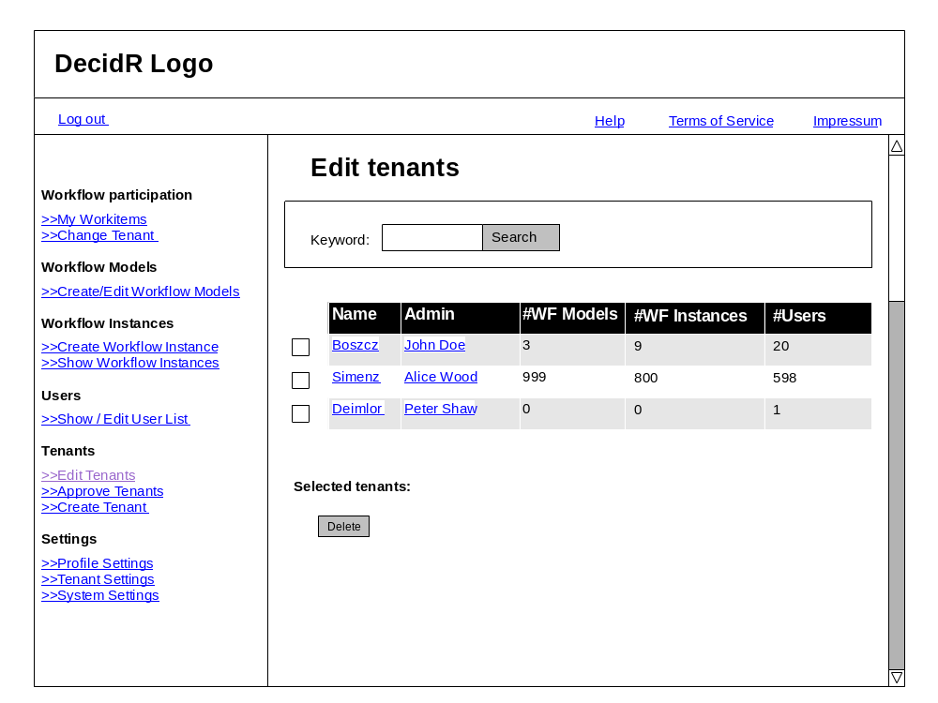
Figure 15: edit tenants

Approve Tenants
In this section the super admin can approve or decline tenant registrations.
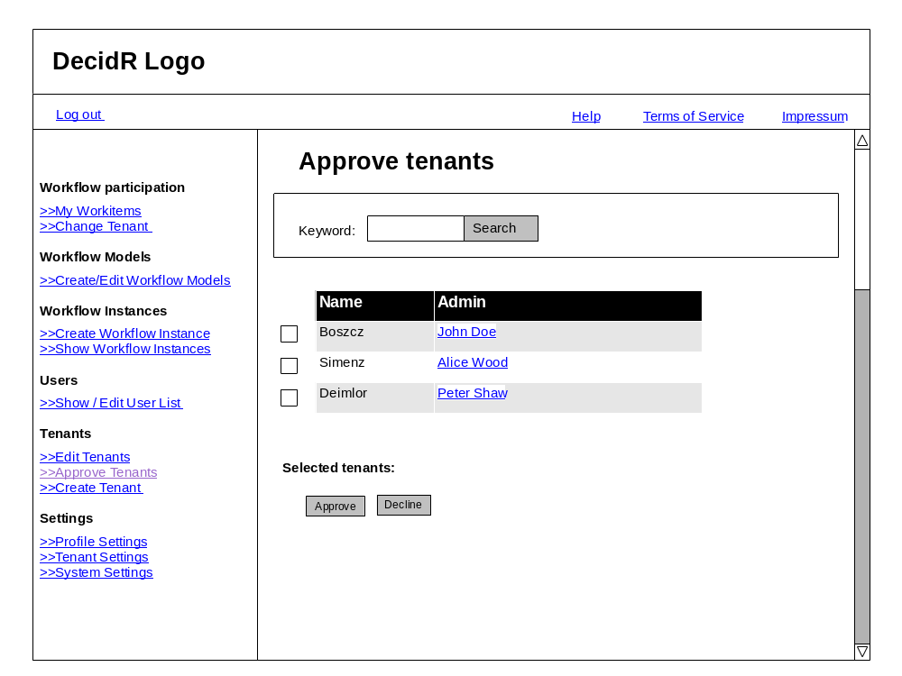
Figure 16: tenant approval

System Settings
In this section the super admin can change the log level and can choose whether tenants registrations should approved automatically or not.
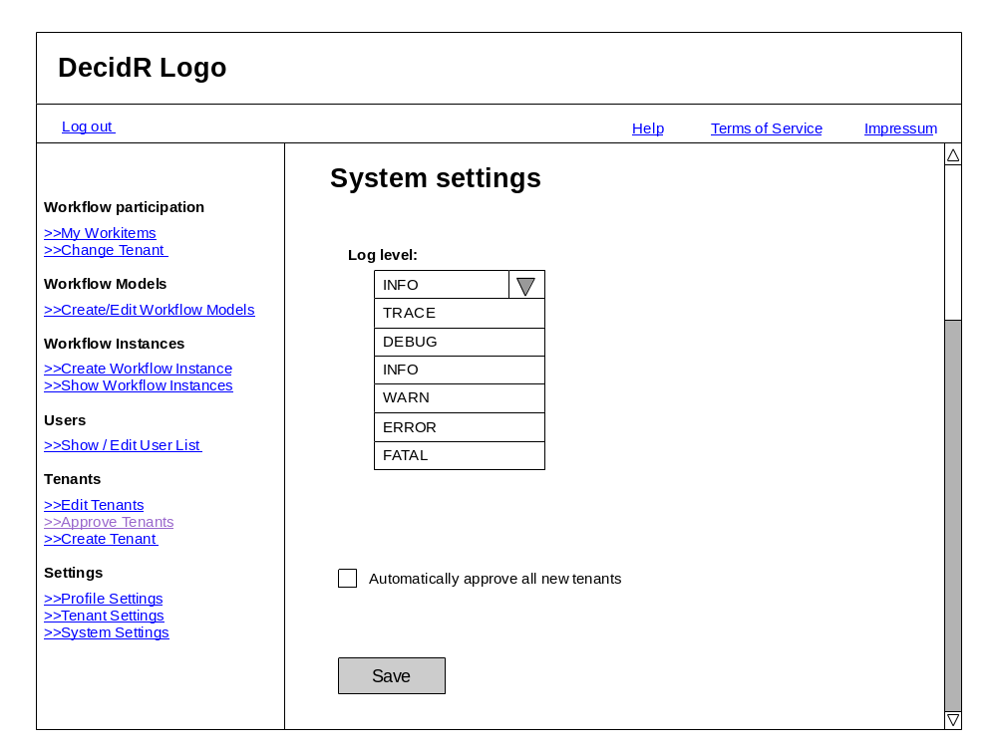
Figure 17 system settings

Show /Edit Users
On this page the super admin can show all users. He is able to delete, create and change user data tenant wide.
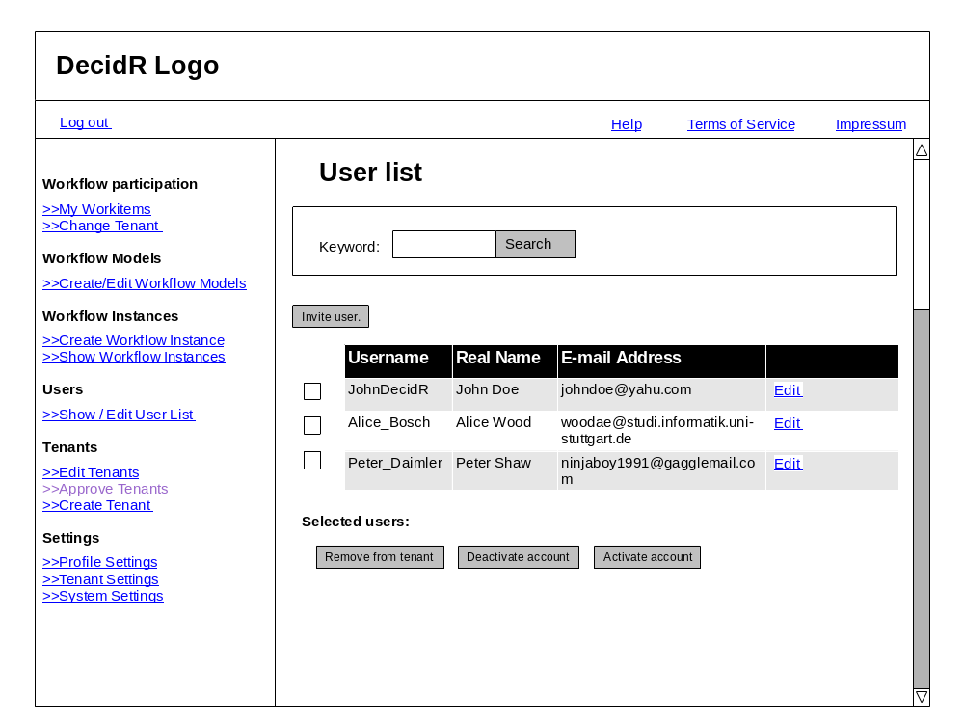
Figure 18 edit users (super admin)

